Practical 2: Property Buying & Rental Process (Chennai City) using Cloud Service Provider (SaaS)
Aim
To create a simple cloud-based Property Buying and Rental application for Chennai city using a Cloud Service Provider to demonstrate the Software as a Service (SaaS) model.
Procedure
- Log in to a Cloud Service Provider.
- Create a new cloud application.
- Design a property registration form with fields such as Property ID, Property Type, Location, Owner Name, Contact Number, Price/Rent, Availability, and Customer Details.
- Store all property information in a cloud database.
- Create forms for property booking, updating, deleting, and searching.
- Enter sample property details for different locations in Chennai.
- Verify that users can access property information online.
- Publish the application as a SaaS solution.
Implementation
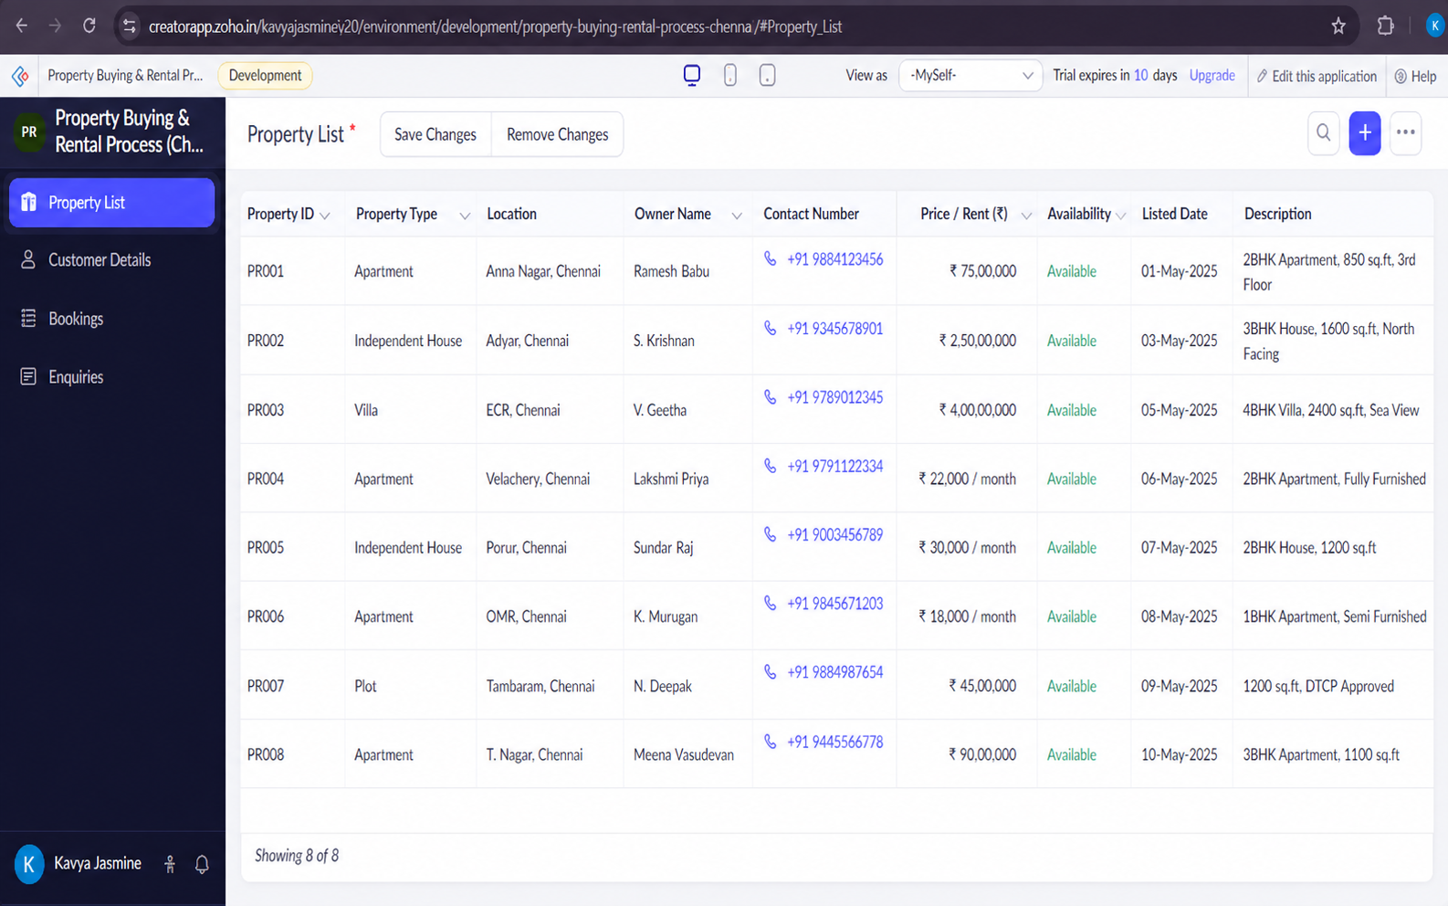

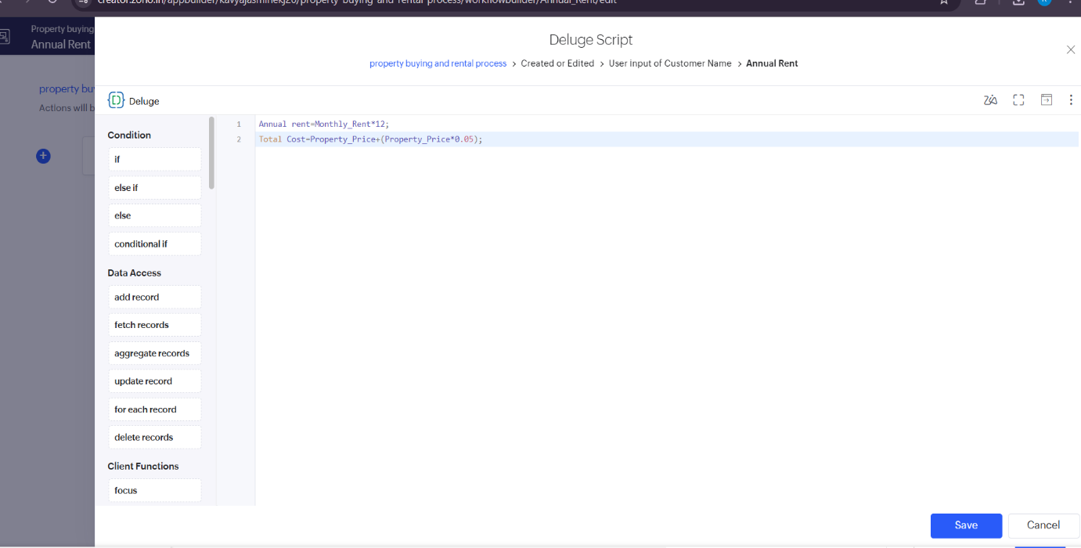

Result:
The formula was successfully implemented in Zoho Creator. The application automatically calculates and displays the Annual Rent by multiplying the monthly Price/Rent by 12, reducing manual calculations and ensuring accurate rental cost estimation.

